WE ARE BIG, INC.

**Submitted by:**

**Group I:**

**Prerana Reddy Ananth**

**Ruchika Narang**

**Sanchit Singh**

**Girish Garg**

**Abhinay Sariswal**

**Date:**

**05/13/2018**

GREEN COMPUTING RESEARCH PROJECT

 

**Table of Contents**

**PART 1: PROJECT INTEGRATION MANAGEMENT** 2

**TASK 1.1: GREEN COMPUTING DESCRIPTION** 2

**TASK 1.2: WEIGHTED DECISION MATRIX** 4

**TASK 1.3: FINANCIAL ANALYSIS FOR BUSINESS CASE** 6

**TASK 1.4: PROJECT CHARTER** 7

**TASK 1.5: UPDATE CHANGE REQUEST FORM** 9

**PART 2: PROJECT SCOPE MANAGEMENT** 11

**TASK 2.1: REQUIREMENT TRACEABILITY MATRIX** 11

**TASK 2.2: SCOPE STATEMENT (VERSION 1.0)** 13

**TASK 2.3: WORK BREAKDOWN STRUCTURE** 14

**TASK 2.4: GANTT CHART** 16

**PART 3 PROJECT TIME MANAGEMENT** 17

**TASK 3.1: ADDITIONAL ACTIVITIES** 17

**TASK 3.2: MILESTONE (SMART CRITERIA)** 18

**TASK 3.3: GANTT CHART AND NETWORK DIAGRAM** 19

**TASK 3.4: HOURS MATRIX** 26

**TASK 3.5: CONTINGENCY STRATEGIES** 28

**PART 4 PROJECT COST MANAGEMENT** 29

**TASK 4.1: PROJECT COST ESTIMATE** 29

**TASK 4.2: PROJECT COST BASELINE** 30

**TASK 4.3: TRACKING THE PERFORMANCE** 31

**TASK 4.4: CORRECTIVE ACTIONS TO MINIMIZE THE COST** 33

# **PART 1: PROJECT INTEGRATION MANAGEMENT**

## **TASK 1.1: GREEN COMPUTING DESCRIPTION**

**WHAT IS GREEN COMPUTING?**

Using computers and their resources wisely in an eco-friendly and environmentally responsible manner is known as *Green Computing*. The development of environmentally sustainable production practices, energy-efficient computers, and improved disposal and recycling procedures are few of the green practices implemented by Information Technology.

**NEED FOR GREEN COMPUTING**

According to a research, in an average year, 24 million computers become obsolete in the United States. Only about 14% (3.3 million) of these get recycled or donated. The remaining are destroyed or shipped as waste products or to be dealt with later in the temporary storage. We even do not care about how our laptop gets disposed of when it dies. Moreover, the electricity being generated from our computers emit harmful gases which can cause respiratory disease, smog, acid rain, and global climate changes.

Therefore, it is high time that we realize to do our part to protect the environment. Here comes the need for green computing which is an important idea to keep our environment clean and safe.

For instance, we can avoid the impact of harmful gases emitted form switched on computers if we save the electricity and do not leave computers switched-on continuously because most of the world's electricity is generated by burning fossil fuel pollutants such as sulphur, mercury, and carbon dioxide.

***10-steps to develop a more environment-friendly IT department in a company***

1. Proclamation of the Green Intentions
2. Appointment of a Working Group for Green IT Compliance Assurance:
3. Measurement of Current Carbon Footprints Produced by IT Components:
4. Planning More Centralized IT Operations:
5. Usage of More Efficient Computer Applications:
6. Usage of More Efficient Cooling Systems:
7. Careful Weightage of Life-cycle of IT Devices and Accessories
8. Business Performance Enhancement through Green IT Policies
9. Work with Everyone Involved in IT Process Life-cycle
10. Result Monitoring and Continuous IT Optimization

**GREEN COMPUTING FOR A SAFE COMPUTER WORLD**

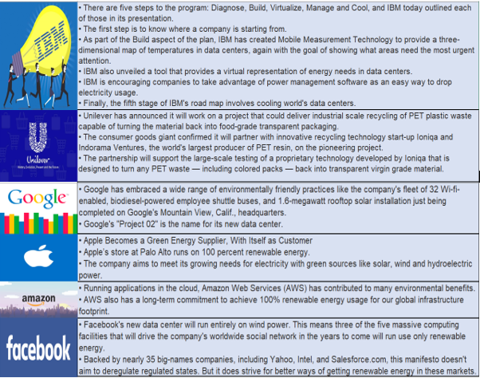

Figure 1: Green computing efforts by renowned IT administrations

**REFERENCES:**

<https://www.techopedia.com/definition/14753/green-computing>

<https://www.greenbiz.com/article/unilever-unwraps-plan-closed-loop-plastic-food-grade-packaging>

<https://www.greenbiz.com/news/2007/05/02/green-computing-google>

<https://www.greenbiz.com/news/2007/05/09/ibm-launches-billion-dollar-project-big-green>

<https://blogs.sap.com/2017/07/12/10-steps-to-implement-green-computing/>

<https://www.nytimes.com/2016/08/24/business/energy-environment/as-energy-use-rises-corporations-turn-to-their-own-green-utility-sources.html>

<https://aws.amazon.com/about-aws/sustainability/>

<https://www.wired.com/2015/07/facebook-wind-powered-data-center/>

## **TASK 1.2: WEIGHTED DECISION MATRIX**

One of the most crucial parts of running a successful project is choosing the right Project Manager. The weighted decision matrix is an effective method for selecting the Project Manager based on various aspects of a successful project. Here we have listed different criteria based on which any candidate is evaluated. The candidate who scores the highest point as per the weighted decision matrix is selected as the Project Manager of the Green Computing Project. The 8 evaluation criteria are listed below:

|  |  |
| --- | --- |
| 1. Project Management Experience | 1. Time Management |
| 1. Leadership | 1. Potential to manage the project |
| 1. Communication and Coordination | 1. Reliability and Dedication |
| 1. Technical Skills | 1. Effective writing capabilities |

The weighted decision matrix below shows the weights assigned to each criterion based on the level of significance. The candidate with the highest aggregate score is highlighted.

|  |  |  |  |  |  |  |
| --- | --- | --- | --- | --- | --- | --- |
| **Criteria** | **Weight** | **Abhinay Sariswal** | **Girish Garg** | **Prerana Reddy** | **Ruchika Narang** | **Sanchit Singh** |
| Project Management Experience | 20% | 50 | 60 | 85 | 90 | 95 |
| Leadership | 10% | 70 | 70 | 65 | 90 | 85 |
| Communication and Coordination | 15% | 50 | 80 | 65 | 90 | 80 |
| Technical Skills | 20% | 90 | 80 | 75 | 80 | 90 |
| Time Management | 5% | 20 | 50 | 90 | 70 | 50 |
| Potential to manage the project | 10% | 40 | 40 | 70 | 80 | 70 |
| Reliability and Dedication | 10% | 70 | 80 | 80 | 90 | 70 |
| Effective writing capabilities | 10% | 40 | 60 | 95 | 80 | 70 |
| **Total Weighted Aggregate** | **100%** | **59** | **68** | **77** | **85** | **81** |

Table 1: Weighted Decision Matrix

Figure 2: Representation of weighted score comparison by applicants

We have considered the application of five candidates for the Project Manager position of the Green Computing Project. The decision matrix shows the different criteria based on which the candidate has been evaluated. There are some pointers which are highly relevant and have larger weights such as, project management experience 20%, technical skills 20%, and communication & coordination 15%. A candidate scoring higher in the above segments has a higher chance to secure the position. Rest of the criteria include leadership, potential, reliability and dedication, and effective writing which hold 10%, and time management 5%.

It is always an advantage to have a Project Manager who is knowledgeable in most of the aspects of the project. Project management experience and technical skills are one of the several critical criteria for choosing a manager. These 2 criteria have a combined weight of 40%. The candidates are expected to have a good knowledge about Green Computing projects.

“Ruchika Narang” with the highest weighted aggregate score of 85 is chosen as the Project Manager. Her score is followed by “Sanchit Singh,” 81, “Prerana Reddy,” 77, “Girish Garg,” 68, and the lowest score being 59 for Abhinay Sariswal.

## **TASK 1.3: FINANCIAL ANALYSIS FOR BUSINESS CASE**

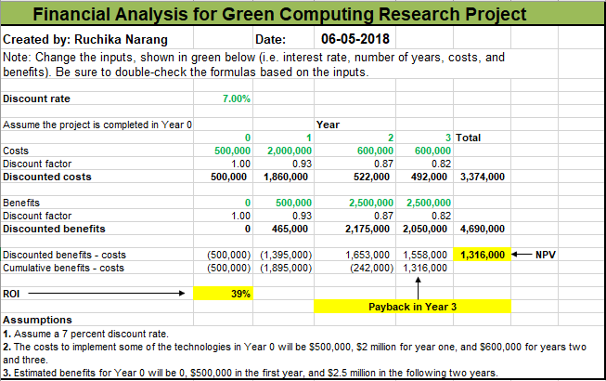

Figure 3: Financial analysis for business case

The figure above shows the results of the financial section of a business case for the Green Computing Research Project. On the bottom left of the figure, we have outlined the three assumptions which helped calculate the discounted factor, discounted costs, discounted benefits, total Net Present Value (NPV), and Rate of Interest (ROI). The template helped us calculate the discount factor at 1.00, 0.93, 0.87, and 0.82 for each consecutive year 0, 1, 2, and 3. The total NPV for our business case is $1.3 million at the end of Year 3. The “Discounted benefits – costs” shows that there is no payback calculated till the end of Year 2. However, the results are different for Year 3 where the payback is estimated to be $1,558,000. The ROI of 39% seems promising, which is a progressive result for a new project. To summarize, as per the assumptions and results, the range of investment offered over the consecutive years will provide promising results in the long run.

## **TASK 1.4: PROJECT CHARTER**

**Project Title**: Green Computing Research Project

**Project Start Date:** 06/01/2018 **Projected Finish Date:** 12/17/2018

**Budget Information:** The firms allocated $500,000 for this project. Majority of the cost will be internal labor, which is $300,000.

**Project Manager:** Ruchika Narang, 425-625-1234, ruchikan@wearebig.com

**Project Objectives:** Research possible application for Green Computing**,** which includes the following

* Data center and overall energy efficiency
* Disposal of electronic waste and recycling
* Telecommuting
* Virtualization of server resources
* Thin client solutions
* Use of open source software
* Development of new software to address green computing for internal use and potential sale to other organizations

**Main Project Success Criteria:** The project should pay for itself within five years of completion.

**Approach:**

* As per Ben suggestion, I am going to use decision support model for this project. Below are some of the steps involved:
* Hand pick the team member with the help of HR department
* Hire outside consultant for project review
* Create a Series of research report
* Pick the top four project ideas from each team

**Roles and Responsibilities**

|  |  |  |  |  |
| --- | --- | --- | --- | --- |
| **Role** | **Name** | **Organization/**  **Position** | **Contact Information** | **Signature**  **(Initials)** |
| Sponsor | Ben | CIO | [ben@wearebig.com](mailto:ben@wearebig.com) |  |
| Project Manager | Ruchika Narang | Manager | [ruchikan@wearebig.com](mailto:ruchikan@wearebig.com) |  |
| Program Manager | Sanchit Singh | Manager | [sanchits@wearebig.com](mailto:sanchits@wearebig.com) |  |
| Outside Consultant | Preranareddy Ananth | Consultant | [preddy@wearebig.com](mailto:preddy@wearebig.com) |  |
| Team Member | Girish Garg | Systems Analyst | [girishg@wearebig.com](mailto:girishg@wearebig.com) |  |
| Team Member | Abhinay Sariswal | Green Computing Expert | [abhinays@wearebig.com](mailto:abhinays@wearebig.com) |  |

Table 2: Roles and responsibilities matrix

**Sign-off:** (Signatures of all above stakeholders. Can sign by their names in the table above.)

**Comments:** (Handwritten or typed comments from above stakeholders, if applicable)

I am ready to provide all the resources that would help in making this project a success. I would be committed to the work and expect others working on a project to show a high level of commitment-Ben Jones.

## **TASK 1.5: UPDATE CHANGE REQUEST FORM**

**Change Request** **Form, or *Change Form***, records a request for change to meet a team's objectives. For instance, a Project Manager may utilize a Change Form to request a change in the scope of a project. The advantage of using a Change Form is to document each change in the project before it is approved by the Project Manager. Anyone in a project team should be required to fill a Change Form with the Project Manager being ultimately responsible for its approval. Without proper change control, teams usually encounter error codes, cost overruns, and relative delays. However, with the implementation of this Change Request Form, the Project Manager can monitor and control change, substantially improving the chances of success of the project.  
The Change Request Form will help the team to:

* Identify all changes before they occur
* Rank the change urgency
* List the costs and benefits of adopting the change
* Implement a formal change approval process
* Control the extent to which changes are approved
* Monitor the effects of change implemented

If anyone among the team members wants to request a change to any component of the project, then one should document this request for change on a Change Request Form. On this form, the team member will provide all the details requested by the form with appropriate reasons. Any supporting documents are attached to the Change Form before presentation to management for approval. By using this Change Request Form to document change requests, the Project Manager can control all the changes in the organization which helps minimize error and cost, maximize profit and manage changes on this project in a timely manner.

***CHANGE REQUEST FORM***

|  |  |  |  |  |  |
| --- | --- | --- | --- | --- | --- |
| **SUBMITTER - GENERAL INFORMATION** | | | | | |
| **Project Name:** |  | | | | |
| **Date Request Submitted:** |  | | | | |
| **Title of Change Request:** |  | | | | |
| **Change Order Number:** |  | | | | |
| **Submitted by:** | **(name and contact information)** | | | | |
| **Priority** | **Scope** | **Scheduled** | **Cost** | **Technology** | **Other** |
| **Description of change requested:** |  | | | | |
| **Events that made this change necessary or desirable:** |  | | | | |
| **Justification for the change/why it**  **Is needed/desired to continue/complete the project:** |  | | | | |
| **Impact of the proposed change on:** |  | | | | |
| **Scope:** |  | | | | |
| **Schedule:** |  | | | | |
| **Cost:** |  | | | | |
| **Staffing:** |  | | | | |
| **Risk:** |  | | | | |
| **Other:** |  | | | | |
| **Suggested implementation if the change request is approved:** |  | | | | |

|  |  |  |  |
| --- | --- | --- | --- |
| **CHANGE CONTROL BOARD – DECISION** | | | |
| **Name** | **Position** | **Date** | **Approve/Reject** |
|  |  |  |  |
|  |  |  |  |
|  |  |  |  |
|  |  |  |  |

# **PART 2: PROJECT SCOPE MANAGEMENT**

## **TASK 2.1: REQUIREMENT TRACEABILITY MATRIX**

**Prepared by:** Sanchit Singh & Ruchika Narang  **Date:** 06/07/2018

|  |  |  |  |  |  |
| --- | --- | --- | --- | --- | --- |
| **Requirement No.** | **Associated ID** | **Name** | **Category** | **Source** | **Status** |
| **001** | 1.0 | Project Justification | Project Charter | Business Case | Completed |
| 1.1 | Candidates screening and evaluation | Project Team Formation | Project Charter | Ongoing |
| 1.2 | Project execution and control guide documentation | Project Management Plan | Project Charter | Pending |
| 1.2.1 | Collection of all project’s processes | Project Statement | Project Charter | Pending |
| 1.2.2 | Documentation of project’s requirements | Project Management Plan | Project Management Plan | Ongoing |
| 1.2.2.1 | Project’s definition, traceability matrix, and deliverables | Requirements Management Plan | Requirements Management Plan | Pending |
| **002** | 2.0 | Organizes team’s work into manageable sections | WBS | Scope Management Plan | Ongoing |
| 2.1 | Finalized WBS, WBS dictionary, and the project scope statement | Scope Management Plan | Scope Management Plan | Ongoing |
| **003** | 3.0 | Establish policies and procedures used to develop, execute, monitor and control the project schedule | Schedule Management Plan | Project Management Plan | Pending |
| 3.1 | Develop detailed list of all project’s activities | List of activities | Project Management Plan | Pending |
| 3.2 | Establish fixed timeline measurement for accomplishment of project tasks | Schedule Baseline | Schedule Management Plan | Pending |
| **004** | 4.0 | Develop time-phased spending plan for the project | Cost Baseline | Cost Management Plan | Pending |
| **005** | 5.0 | Develop management strategies to engage stakeholders effectively | Stakeholders Registration | Project Management Plan | Pending |

Table 3: Requirement traceability matrix

In the next part of this section we have listed questions relating to our project scope to discuss with our Project Sponsor, Ben.

***List of questions to the Project Sponsor, Ben about the scope:***

1. What are the business goals the project is aiming to achieve?
2. What is the project deadline? What are the factors or events that are calling for that date?
3. Will the organizations within your company be affected by this?
4. Will You Provide the Necessary Support?
5. What are the success criteria that will indicate the objectives have been met and the benefits delivered?
6. Are there any dates when you will be closed or not available?
7. Has your team been through a project like this in the past?
8. Is there anything (risks or issues)that would prevent the project from being successful?
9. Are there any security issues?
10. Do you have specific performance requirements?
11. Has the project sponsor described the risk to the organization if the project is not completed?
12. Is there a preferred mode of communication?

## **TASK 2.2: SCOPE STATEMENT (VERSION 1.0)**

|  |
| --- |
| **Project Title:** Green Computing Research Project  **Date:** 06/12/2018 **Prepared by:** Sanchit Singh & Ruchika Narang |
| **Project Justification:** The business goal of the project is to come up with recommendations for establishing a safe and eco-friendly computer world while increasing corporate revenues and decrease operational costs. This involves researching possible applications of green computing and developing series of research reports and project proposals based on ideas and strategies for implementing green computing in organizations. |
| **Product Characteristics and Requirements:**   1. Environment- friendly 2. Energy conservation 3. Server resources virtualization 4. Low server utilization rates 5. Development of eco-label software and hardware 6. Project and data management 7. Complete deliverables within time frame 8. Telecommuting 9. Increase revenue 10. Cost management and reduction |
| **Summary of Project Deliverables**  **Project management-related deliverables:** business case, charter, team contract, scope statement, WBS, schedule, cost baseline, status reports, final project presentation, final project report, lessons-learned report, and any other documents required to manage the project.  **Product-related deliverables:** research reports, design documents, software code, hardware, etc.   1. Possible green computing technologies to implement 2. 20 different project ideas for these technologies 3. Decision support model for analyzing the project ideas 4. Top 4 recommended solutions selected among these project ideas 5. Requirements traceability matrix |
| **Project Success Criteria:** The success criteria that will indicate the objectives have been met and the benefits delivered are the increase in revenue with reduced cost, consistency of each deliverable with the requirements, and the completion of each deliverable within the designated timeframe. |

## **TASK 2.3: WORK BREAKDOWN STRUCTURE**

# **Prepared by: Sanchit Singh & Ruchika Narang Date: 06-09-2018**

# Initiating

## Assigning task to team members

## Research on Green Computing

## Kick Off meeting

## Prepare business case

## Prepare project charter and sign

## Create change request form

# Planning

## Create a Project Plan

### Requirement tracking matrix

### Set up a scope statement

### List down the work breakdown structure

### Create a Gantt Chart

## Create a backup plan

# Analysis

## Virtualization of server resources

### Identify the effort involved in physical server virtualization

### Analyze the reduction of space, energy and capital

## Disposal of electronic waste and recycling

### Cost analysis

### Identify the benefits

### Effort prediction

## Data Centre and overall energy efficiency

### Analyze the current energy consumption

### Prepare energy consumption reduction plan

### Finalize the approach

## Development of new software to address green computing

### Analyze the benefits of internal use

### Analyze potential sale to other organizations

# Implementation

## Propose solution

### Design and code

### Create prototype

### Create software to address green computing

## Testing

### Create testing environment

### Test the product in different cycles- development, training, UAT

### Track defects until resolution

# Performance Report

## Change request analysis

## Requirement discussion

## Approve change request

# Project documentation and next release plan

## Submit project report

## Present final project report

## Project completion

## **TASK 2.4: GANTT CHART**

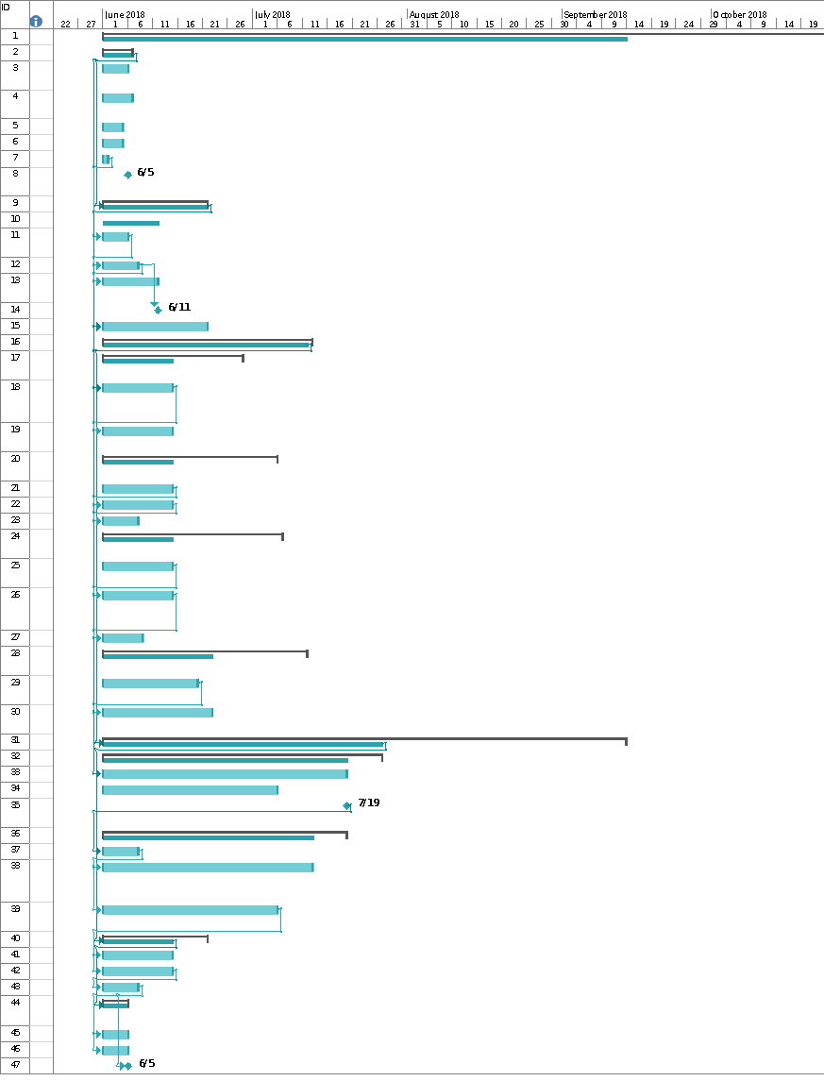

# **PART 3 PROJECT TIME MANAGEMENT**

## **TASK 3.1: ADDITIONAL ACTIVITIES**

**Additional activities to scale up the kick-off:**

Ito, the program manager and Ben, the project sponsor, suggested us to speed up the task of selecting tools that will be utilized in the Green Computing project. Ben has proposed to grant additional funds if required but, wants us to deliver a good product within the schedule. Hence, we have reviewed the WBS and the Gantt Chart from the previous task and have included additional activities which are listed below:

**Additional activities to estimate resources and durations:**

1. **Final project documentation coordination:** Deb would need a few resources to create the final documentation of the Green Computing project after implementation. We have identified Le, the new hire to take the lead on this activity as she has a doctoral degree with a thesis in Green Computing. Her availability onsite will be an added advantage for us to coordinate with Deb and provide him with the required information. Our goal is to efficiently collaborate on the final project report and involve James for the presentation.
2. **Collaborative tools selection:** We have accelerated the process of selecting tools for collaboration. The project team is on track with the new timelines and we will have the tools decided for implementation as per the deadlines. Ben and Ito are happy with this notification.

We have set up a meeting with the IT department to brainstorm the collaboration ideas around Green Computing.

1. **Bi-weekly meeting:** We have chosen Le to coordinate with the relevant stakeholders to conduct a Skype meeting including the customer, where at least one senior member is responsible for representing each vendor. The agenda will be to brainstorm ongoing issues and tasks to be accomplished before the next meet up. Ben and Ito along with some senior executives would be attending the meeting to evaluate the progress of the project. Weekday and meeting time will be decided by as per the availability of the attendees.
2. **Task scheduling:** We are using the “Project Evaluation and Review Technique” popularly known as “PERT” to estimate the milestones and timelines for the completion of this project. A one-week buffer has been added to align with the preparation of the final project report.

## **TASK 3.2: MILESTONE (SMART CRITERIA)**

List of four milestones for Green Research Project:

|  |  |  |
| --- | --- | --- |
| **S/No.** | **Milestone** | **Descriptions** |
| **1** | **Prepare project charter and sign** | This document is the project proposal that has been agreed by all the members. Upon completion of each milestone, we will have several tasks completed such as kick off meeting, identifying the team members for the project, developing a business case, and developing a project charter. This milestone will be completed in a month after all the team members have signed the project charter. Also, completion of this milestone marks the beginning of the next milestone (i.e. Milestone 2) of our project. |
| **2** | **Complete creation of Gantt chart** | This milestone depends whether the project plan has been reviewed completely and is planned to be completed within 3 weeks. It will be marked as completed when the project idea is approved. Important documents like requirement matrix, scope statement which defines how the work would be done have been created by the end of this milestone. Deliverables and important tasks are discussed within the senior management and put into writing for everyone to be on the same page. This milestone will lay down a path for the next milestones. |
| **3** | **Create software to address Green Computing** | Product development will be marked completed by the end of this milestone and since it is the longest phase, it will take close to 3 months. A prototype is developed based on the results with a research on all the application with different features. The software is in the designing, development and testing phase and several outcomes have been proposed with respect to the outcome. The changes required to be made in the applications are accepted and is ready to be released. Project sponsors and manager would take responsibility for the timely delivery of the software. The required software has been delivered to the user successfully. |
| **4** | Project completion and delivery of the final project | Overall project is marked completed in this milestone. All the work performed during the project have been documented and a project report is being created. The report has been created by the project manager covering all the details of the project from the beginning to the very end. This project report is delivered to the clients as well as the project sponsor. |

## **TASK 3.3: GANTT CHART AND NETWORK DIAGRAM**

***Gantt Chart***

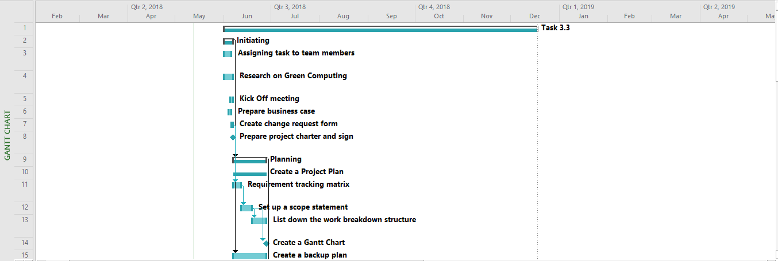



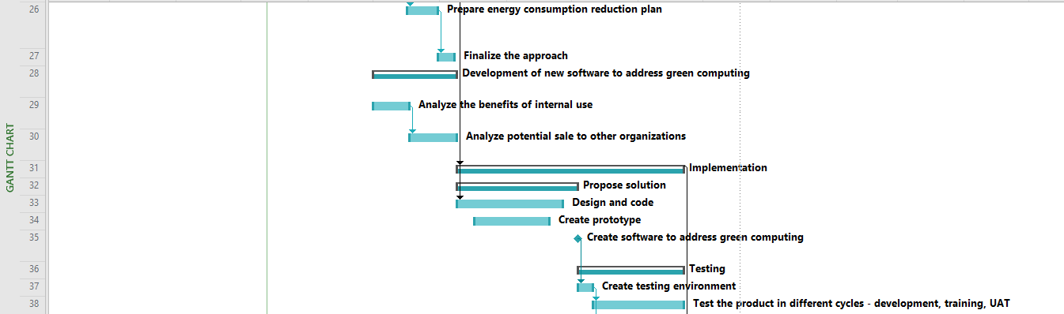

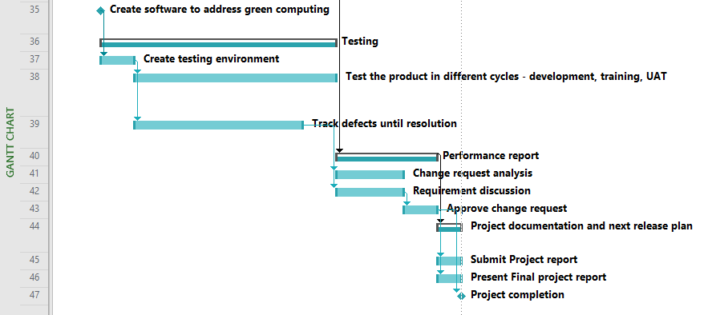

Figure 4: Gantt Chart

***Network Diagram***





Figure 5: Network diagram

## **TASK 3.4: HOURS MATRIX**

Though every project will always have a Project Manager who assigns tasks to his/her team members; sometimes certain tasks are overlooked. Assigning tasks to a team is an indispensable element of any leader’s responsibilities. Effective delegation in management is what makes a team function as a well-oiled machine.

Once you’ve identified tasks that can be delegated to other members of your team, you need to consider who the best person is to take them on. Make sure that the individual you select has the skills needed to tackle the task, and that it’s not too easy for them. Another important part of the selection is to determine the values and character traits a person has because the critical responsibility is to assign right task to the right people. It is very important to assign the right task to the right person. It affects the efficiency and speed of the project. Moreover, if different people are working on the different tasks at the same time, it makes the process faster.

It’s not enough to assign a task to a team member. You need to give people full authority over the work, so they feel engaged to complete it successfully. You also must make sure that when you transfer a task, the assigned person has taken complete responsibility for it.

In that case, following are the criteria from which the decision can be made.

1. Who is being under or overworked?
2. Who is the most skilled?
3. Who has worked on the similar project or task in the past with the required skills?
4. Whom to assign congruent activities?
5. Who is the best to work in a team?

Given below is the chart that shows the numbers of hours needs to be worked on each task and who will be responsible for each task.

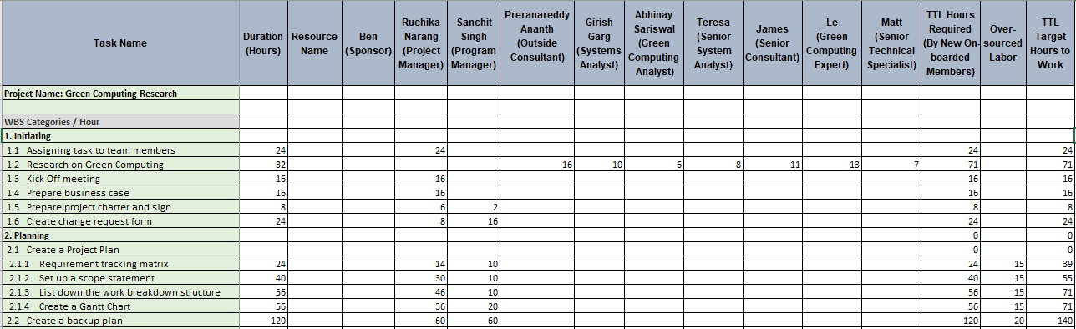

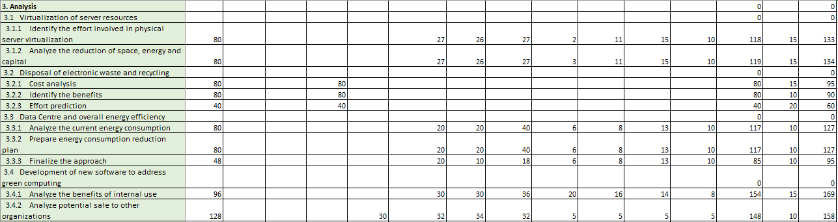

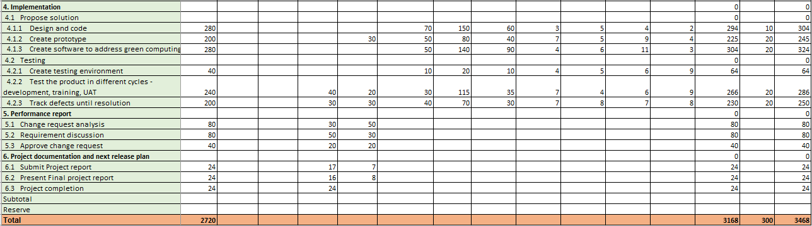

Figure 6: Hours matrix

## **TASK 3.5: CONTINGENCY STRATEGIES**

1. **PERT analysis:**

The project evaluation and review technique (PERT) is a network analysis technique used by managers to calculate the time duration required for completing a certain task or the overall project. It helps in tracking the time-period consumed in doing a certain activity and also calculates the optimistic time and the most likely time to complete that particular task allotted, thus helping in proposing the future strategies to be followed in order complete the project in the desired time.

1. **Resource allocation:**

Resource allocation involves bringing in extra hands to complete the project within the desired frame of time. We can allot pending tasks to these resources so that the current team can continue to focus on their scheduled tasks. This strategy can bring back the project on track, if not affected by the budget issues.

1. **Swapping of resources:**

Swapping of resources is a very useful technique to bring back the falling project on schedule. All the members of the team are not equally skilled, and the project mostly lags the schedule because of few less productive resources. Therefore, we can assign some other tasks to these resources which they are good at and can bring other resources who are productive in doing the tasks we are focusing on.

1. **Determining Priorities:**

The ideal way of completing the project on time is by prioritizing the remaining tasks and by allocating skilled and productive resources to the completion of these tasks. This technique will help to cover most of the tasks on time.

1. **Reaffirming the roles and responsibilities:**

It is very important to clarify the roles and responsibilities with every team member working under the project. Sticking to those roles and performing their duties timely will help in completing the project before the deadline. It will also eliminate any confusion among the team members related to their roles and the tasks they are expected to perform.

# **PART 4 PROJECT COST MANAGEMENT**

## **TASK 4.1: PROJECT COST ESTIMATE**

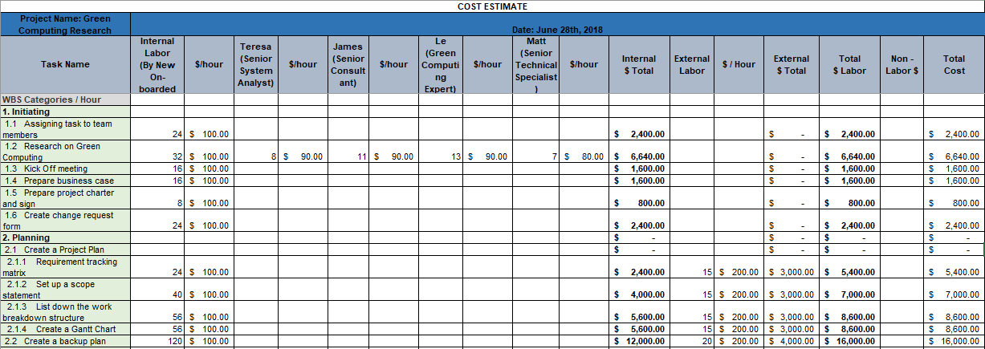

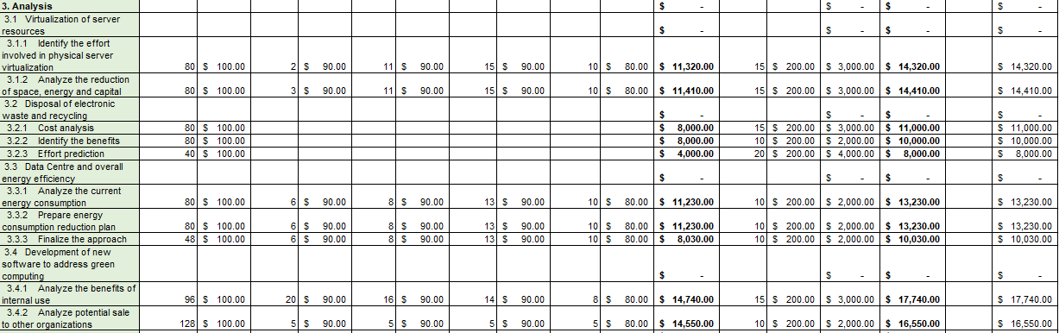

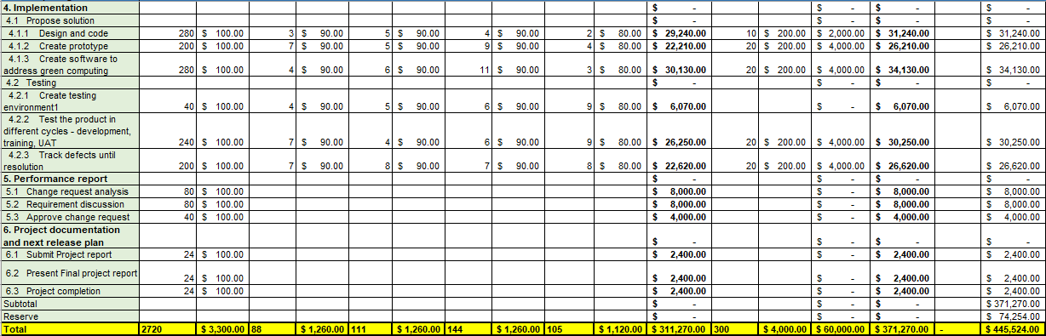

Figure 7: Project cost estimate

## **TASK 4.2: PROJECT COST BASELINE**

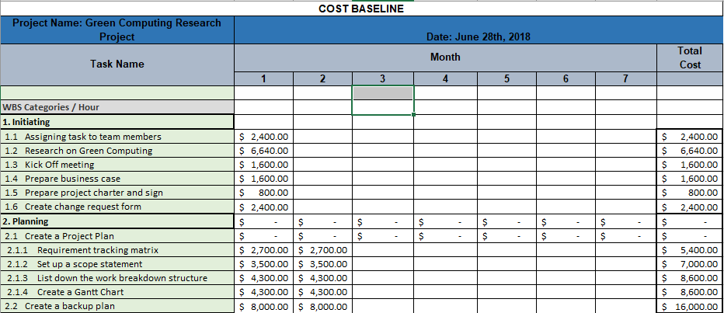

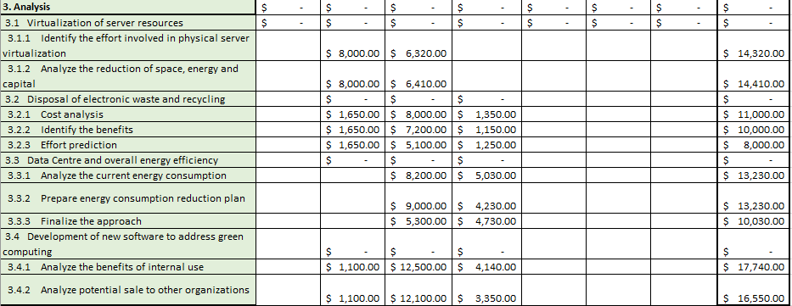

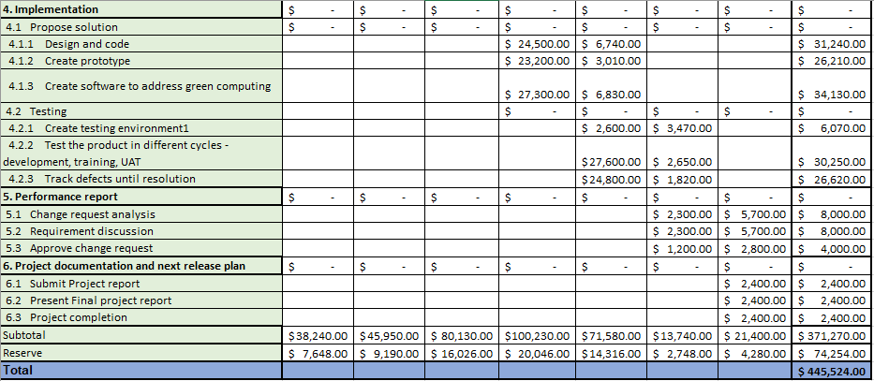

Figure 8: Project cost baseline

## **TASK 4.3: TRACKING THE PERFORMANCE**

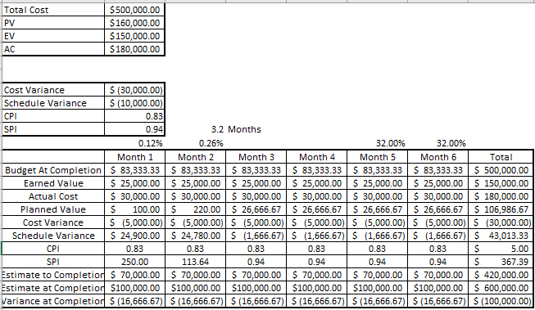

Figure 9: Earned value analysis

1. The cost variance of our project is - $ 30,000. This indicates that the cost has exceeded the allotted budget by $ 30,000. The schedule variance is - $ 10,000 indicating that the earned value is lower than the planned value by $ 10,000. The CPI is 83% and the SPI is 94%, which means that we are 6% behind schedule.

Figure 10: EVM (Earned value management) chart

1. The graph shows the pictorial representation of the performance of the project. The data given best explains the current performance of the project after 3 months because it is a quantitative analysis rather than a qualitative statistical analysis. While looking at the overall progress, we took 0.2months more than that of the projected plan at the beginning. Also, another crucial factor is that it implies that the project will be over budgeted by $100k.
2. It is very important for us to take extra steps to ensure that the project is completed not only on time but also within the budget, if not, this will be a failure. The project sponsor should be made aware and support should be taken from the senior management to keep make sure that the project does not exceeding the budget.

## **TASK 4.4: CORRECTIVE ACTIONS TO MINIMIZE THE COST**

1. **Consultant cost:** A significant time was lost due to the communication gap within the consultant's organization which contributed to the delay in specific activities. We detected the problem and increased our involvement with the consultant. We set expectations from the project manager representing the consultant to send us regular updates on the status and progress of the tasks. We asked each vendor to create a task matrix for tracking the ongoing activities to avoid similar cost incurred due to delay. This measure reduced the expected delay by quite a significant margin.
2. **Weekly meetings:** We scheduled a recurring weekly meeting on every Wednesday whose attendees included the critical stakeholders from the organizations involved in the implementation of the Green Computing Project, and the developers who wanted to discuss the issues encountered during development of vital requirements with the significant vendors. The meeting allowed an open-ended discussion where problems were troubleshot on a high level, and the attendees expressed their opinion regarding the matter. The meeting helped in clearing the communication gap and enabled us to set task-level priorities for the respective vendors.
3. **Travel cost:** The travel cost seemed to exceed the expected value during the kick-off phase. There were costs involved when the employees had to travel and coordinate with vendors for essential implementation strategies. There were also instances when the vendors had to visit our team for similar situations. We modified the approach and reduced this cost by organizing online web meetings. We assigned significant responsibilities to employees who worked diligently to be on top of the major tasks involved in completing the project. The weekly meeting was leveraged as a strategy that enabled effective coordination and cost-cutting.